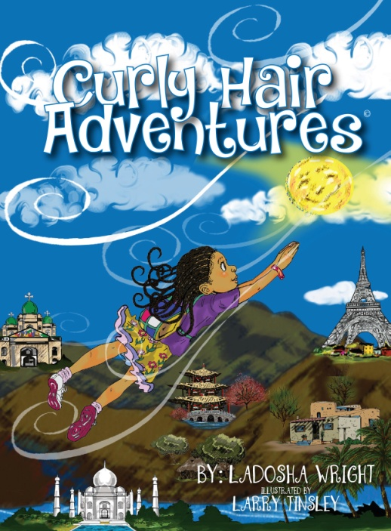

FOR IMMEDIATE RELEASE
Contact: Mrs. Leslie Barrett
216.623.2921
CLEVELAND, OHIO (May 27, 2017)—Ladosha Wright, cosmetologist turned author, has written a children's book, Curly Hair Adventures, designed to educate girls, mothers and all who are interested about the beauty of caring for textured hair. Wright's goal is to promote diversity, parent-child bonding, encourage children to appreciate books and the joy of reading and to debunk any myths about hair texture being determined by race or viewed as "bad."

Event: Book reading and signing of Curly Hair Adventures by author. Q&A session to follow. Books will be available for purchase/order.

When: Saturday, May 27, 2017
2 -4 p.m.

Where: Cleveland Public Library (Main Library)
325 Superior Avenue
Cleveland, Ohio 44114

Cost Free to the public. All are invited. Parents, teachers, daycare workers, hairstylists and Transracial adoptive parents are encouraged to come!

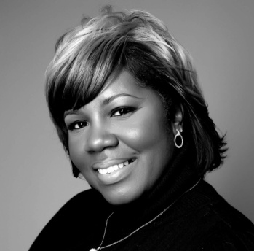
Ladosha Wright is an Ohio State Certified and Licensed Manager of Cosmetology
with the Reverence Design Team Hair Salon. Please visit the team on their website: www.rdthairsalon.com.

Also follow on:

###

