.
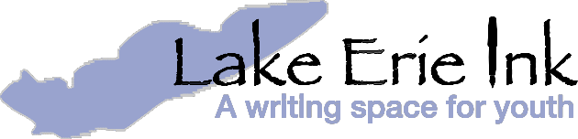

Press Release – For immediate release

Kids and Professional Artists Unite for Lake Erie Ink’s 7th Annual Kids’ Comic Con

Lake Erie Ink will be hosting its 7th Annual Kids’ Comic Con Saturday, March 2, 2019 from 9:30am-3pm. At this all day event, youth of all ages will have the chance to attend workshops with experienced comic creators. Last year, this one-of-a-kind comic convention for young writers and artists drew nearly 150 kids and teens from all across Northeast Ohio. Workshops will cover both aspects of comic creation – drawing and writing – as well as the ever-popular “create your own comic character in clay.”

This year’s featured keynote speaker will be Marc Sumerak . From comics and books to video games and beyond, Sumerak has written for MARVEL, STAR WARS, GHOSTBUSTERS, FIREFLY, HARRY POTTER, and more.

More featured artists and writers include:

Kate Atherton (Illustrator and comics artist)
Sequoia Bostick (Illustrator, children’s author, and founder of Vagabond Comics)
Juan Jose Fernandez (Cartoonist and comics maker)
John G (Illustrator, comics creator, and head of Shiner Comics, Inc.)
Michelle Littlejohn (Mixed media artist)
Miguel Hernandez (Illustrator and designer)
Kelly O’Grady (Writer, cartoonist, and illustrator)
Angela Oster (Artist and author of “Little Vampire Girl” Comic
Don Peoples (Graphic designer, cartoonist, photographer)
Gilberto Rivera (Illustrator, graphic designer & content creator
Lee Smith (Founder of Prosperity Graphics--Comics for the Classroom)
Shawny Walthaw (Freelance graphic designer and illustrator)
Doors open at 9:30am, and workshops begin at 10am. Costumes are encouraged! Admission is $10 at the door, and scholarships are available. Lunch will be sold on-site or kids may bring their own. Comics, graphic novels and t-shirts will be for sale. Adults are welcome if accompanied by a child; teachers are welcome with a staff ID. Register at lakeerieink.org/register or by calling 216-320-4757.

Lake Erie Ink: a writing space for youth is a nonprofit organization whose mission is to provide creative expression opportunities and academic support to youth in the Greater Cleveland community.

Lake Erie Ink is a member of Greater Cleveland Community Shares. Community Shares supports local nonprofit organizations working for long-term, sustainable solutions to build a stronger Cleveland. Learn more about Community Shares and supporting social justice through workplace giving at www.communityshares.org.

Contact Us
Sarah Kloos, Communications and Marketing Manager
2843 Washington Blvd. | Cleveland Heights, OH 44118
P: 216-320-4757 | E: marketing@lakeerieink.org | www.lakeerieink.org

